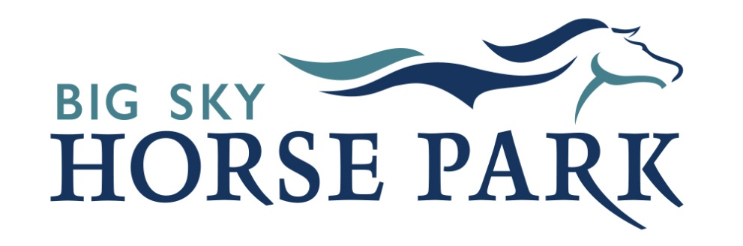

2026 Schedule of Events
January 8th – Membership Appreciation Party
March 14th – St. Patrick’s Day Parade
April 18th – Spring Work Day
April 24-25th – Carol Mayo Dressage and Jump Clinic
April 26th – Dancing in the Sand Dressage Schooling Show
May 2nd – Montucky Derby Fundraising Event
May 2-3rd – 4H Camp
May 16-17th – Five Valleys Pony Club Hunter/Jumper Show
May 23rd – Jumping Derby
May 30-31st – 4H Livestock Clinic
June 7th – BSHP Community Day
June 13th – Family Fun Omoksee #1
June 20th – Flying Colors Mini-Event #1
June 27-28th – WE Under the Big Sky Rated Show
July 6-9th – Pony Club Camp
July 11th – Family Fun Omoksee #2
July 12th – Dancing in the Sand Dressage Schooling Show
July 25-26th – 4H Fair Horse Show
August 8th – Jumper Fun Day
August 22nd – Family Fun Omoksee #3
August 22-23rd – HMFM + Run Wild Missoula 24-Hour Race
August 24-30th – USAWE Region 1 Championships
September 5-6th – Dancing in the Sand Dressage Schooling Show + Clinic
September 19th – Flying Colors Mini-Event #2
October 3rd – Homecoming Parade
October 10th – Halloween Omoksee

